
TRAINING QUESTIONNAIRE
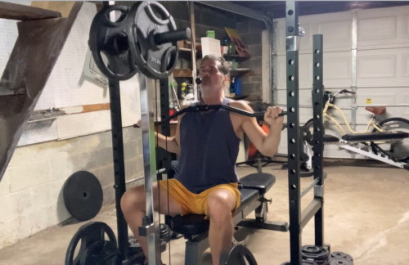
TRAINING QUESTIONAIRRE

Please fill out as candidly and accurately as possible.

Name:

Best email address:

Age:

Sex:

Height:

Weight:

Occupation:

Average hours worked per week:

Any family obligations, ie, dependent children or adults? Yes or No

How many days per week can you devote to training?

How much time can you devote to your workouts, including travel time?

Have you ever done any strength or fitness training? If so, what?

Do you currently play/compete in sports? If yes, which ones? How often?

What are your fitness goals for the next three, six and twelve months, ie, weight loss and/or strength goals? Please describe in as much detail as possible.

Do you currently lift weights? If yes please estimate current strength figures below. Type N/A if don’t know.

Bench press: Max weight for 5 reps -

Squat: Max weight for 5 reps -

Dead lift: Max weight for 5 reps -

Overhead press: Max weight for 5 reps –

Maximum Pushups -

Chin ups (chin ups performed palms facing inward, shoulder width grip):
Maximum # you can perform –

Can you jog a mile without stopping to walk? If so, how many minutes does it take to complete a mile at your regular pace? How far can you jog without stopping to walk?

If you don’t jog, do you do any other cardio exercise (yes, walking counts)? If so, how often, and how long is your typical workout?

Do you have any strength training or cardio equipment at home? If so, describe what you have.

If you don’t have equipment at home, can you go to a gym?

If you prefer to do your workouts at home, and have no equipment, what is your budget for purchasing equipment? Answer N/A if not applicable.

If you will purchase equipment, how much space do you have (please measure)?

Do you do any other forms of exercise, such as Yoga or martial arts?

Do you regularly stretch?

Do you have any injuries or long term physical or medical issues?

What are your favorite types of protein?

Do you have any food allergies?

That completes this questionnaire. I will acknowledge receipt via email, and then have your plan delivered within 3 business days unless otherwise indicated.

Regards,

Scott Cole
Champion of Aging

